**Lab IX**

1. Create the following user, database and table (this information is also included as dbstruct.sql in the zip file)

Username: schooluser

Password: schoolpass

Database Name: school

Table Name: students

Structure of the Table

|  |  |  |  |
| --- | --- | --- | --- |
| **Field name** | **Field Type and size** | **Nulluable** | **Additional Properties** |
| stno | Varchar(6) | no | Primary Key |
| name | Varchar(20) | No |  |
| surname | Varchar(20) | No |  |

1. Implement the following application using PDO (this application is already included with mysql_ commands in this zip file) pay attention to our last topic which covers error handling.

List.php

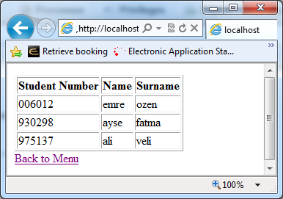

Record Not found

When List button clicked (if there is such a student no)

Search.php

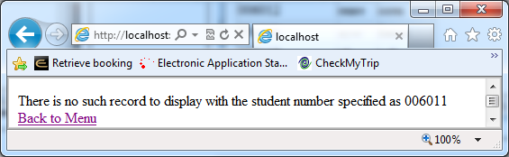

Search.php

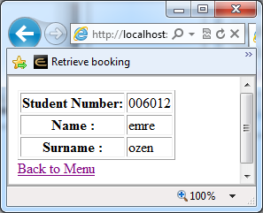

Search.html

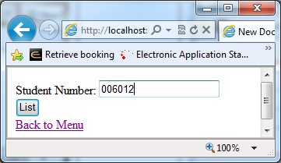

List a Students’ info

List All Records

Menu.html

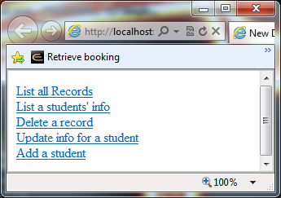

Delete.html

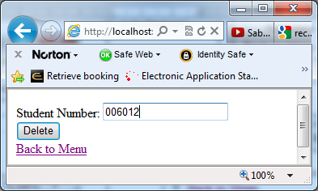

When delete button clicked (if there is no such record)

Delete.php

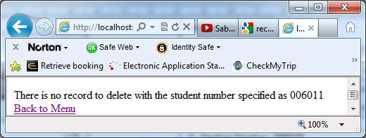

When delete button clicked (if such record exists)

delete.php

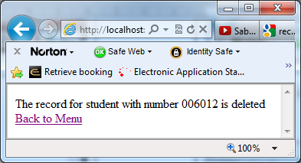

Menu.html



Delete a Record

Show details clciked (If student number exists)

If no such student number in db table (Show details clicked)

Update info for a student

When update clicked

Update.php

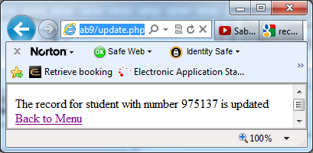

Chkupd.php

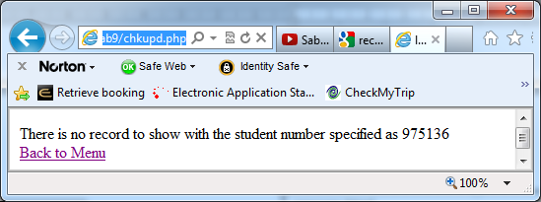

prepare.html

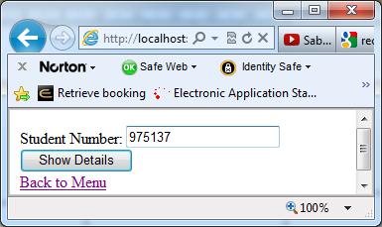

Chkupd.php

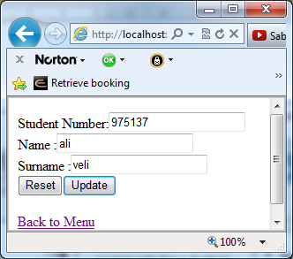

Menu.html



Add button clicked and student number already exists

Add.php

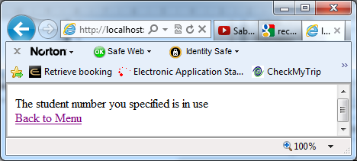

Add button clicked and there is no primary key clush

Add.php

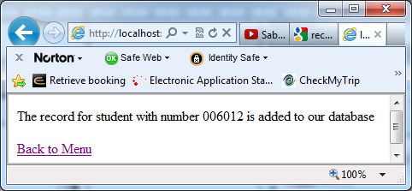

add.html

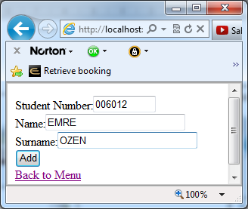

Add a student

Menu.html

